CV
Personal Data
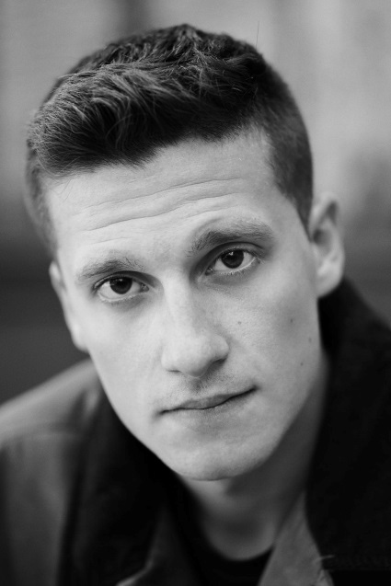 | Name: Yassen Atanassov  Date of Birth: 27.03.1997  Place of Birth: Sofia, Bulgaria  Nationality: Bulgarian  Address: Sofia, 4B “Han Krum” Street  E-mail: iassen_at@abv.bg  Skype: yassen.atanassov  Mobile: +359 893 383 420  Instagram: yassen_at

Education & Trainings

Dates:
14/08/2021 – 19/08/2021 – Participant in the Acting Studio of “Talents Sarajevo 2021”
15/09/ 2017 – 24/05/2021 - Student in NATFA (Sofia, Bulgaria) - Acting for Drama theatre
28/08/2018 – 08/09/2018 – Member of the jury of “Giornate degli Autori” official competition and ambassador of the LUX Film Prize 2018 in Sofia, Bulgaria
May 2017 – IELTS Certificate
27/09/2016 – 27/11/2016 – HdM Stuttgart
15/09/2011 - 24/05/2016 – German High School “Prof. Konstantin Galabov”, Sofia;
Main subjects: German, English, Bulgarian Language and Literature, History
December 2015 – Deutsches Sprachdiplom
June 2015 - Certificate in Cambridge Advanced English – CAE Level C1 by Cambridge English Language Assessment
2011 – 2015 - English Language courses in the British Council and Avo Bell language centre;
Languages
Native Language: Bulgarian
Other languages:
Self-assessment |  | Understanding |  |  |  | Speaking |  |  |  | Writing
European level (*) |  | Listening |  | Reading |  | Spoken interaction |  | Spoken production
English |  | C1 | Proficient user | C1 | Proficient user | C1 | Proficient user | C1 | Proficient user | C1 | Proficient user
German |  | B2 | Proficient user | B2 | Independent user | B2 | Independent user | B2 | Independent user | B2 | Proficient user
French |  | A1 | Basic User | A1 | Basic User | A1 | Basic User | A1 | Basic User | A1 | Basic User
 | (*) Common European Framework of Reference (CEF) level

Artistic skills and competences:

Acting experience in film
- 19.11.2021 – Military guy – in the feature film “Fear” (Strah); dir. Ivailo Hristov (Bulgarian official submission for Best International Feature Film at the 94th Academy Awards)
- 23.03.2021 – Andy – in the feature film “Petya of my Petya”; dir. Aleksandar Kossev (2021 “Golden Rose” award for DEBUT)
- 05.2020 – Angel – in the short movie “A summer in a winter day”; dir. Dimitris Georgiev
- 21.12.2019 – Joseph – in the short film “For every heart”; dir. Chris Zahariev
- 11.2018 – Stan – in the YouTube series “Unilife” Season 1; dir. Georgi Dimitrov
- 2016 - Filming and participating in “Get Lost On Purpose” web series; dir. Chris Zahariev (documentary)
- 2010 The boy (Tony) in the “Voice Over” feature film which was filmed in Bulgaria, Egypt and Germany ( the film won the FIPRESCI and Best director award at the International Film Festival in Cairo); dir. Svetoslav Ovcharov
- 2007 The boy (Anton) - in the Bulgarian National TV series “Lily’s Holidays”; dir. Ivanka Grabcheva
Acting experience in theatre
- 07.2022 – in the role of Vincent van Gogh – in “Vincent in Brixton” by Nicholas Wright – Theatre 199 “Valentin Stoychev, dir. Vladlen Alexandrov
- 12.2021 – in the role of Abbé du Coulmie – in “Marquis de Sade” (“Quills”) by Doug Wright – Theatre Bulgarian Army; dir. Ivan Urumov
- 10.2021 – in the role of Christian – in the “Cyrano de Bergerac” by Edmond Rostand – Theatre Bulgarian Army; dir. Stoyan Radev
- 05.2021 – in the role of Valère – in “The Misner” by Molière (Drama Theatre Ruse); dir: Denislav Yanev
- 12.2020 – in the role of Michel – in “Dialogues de bêtes“ by Sidonie-Gabrielle Colette – Theatre Bulgarian Army; dir. Stefan Spassov
- 02.2020 – in the role of Aralambi – in “Bustle” by Jordan Radichkov – NATFA; dir. Ivailo Hristov
- 11.2019 in the role of Gerald- in the “Woman of No Importance” by Oscar Wilde– professional debut in the one of the leading theatres in Sofia – Theater Bulgarian Army; dir. Stoyan Radev
- 09.2019 – in the role of the first God – in “In searching of the good person” based on “The good person of Szechwan” by Bertolt Brecht; dir. Eva Danailova
- 2008 - 2015 in the role of Nathan in “Full Monty” – Sofia Youth Theatre; dir. Vladimir Liutskanov
- 2007 – 2010 - in the role of Dodger in “Oliver Twist” – Sofia Youth Theatre; dir. Andrey Avramov

Additional Skills:.
- Playing piano, accordion, traditional Bulgarian bagpipe, singing
- Doing break dance, acrobatics and contemporary;
- Driving license
- Professional tour guide certificate.
- Football, Table tennis, Volleyball

