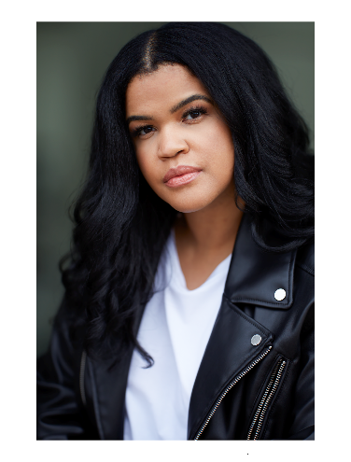
Physical Attributes
Jennifer Freeman Non-Union
Contact: (330)604-6590
Email: jenn.free@outlook.com
Height: 5`6
Weight:175lbs
Eye Color: Brown
Hair Color: Black
Film

Finding Valentine Ms. Juarez (supporting) Timbrel Hildebrand (student film)
Training

The International Acting School Adam Davenport

Hartt & Soul Studio Cathryn Hartt

