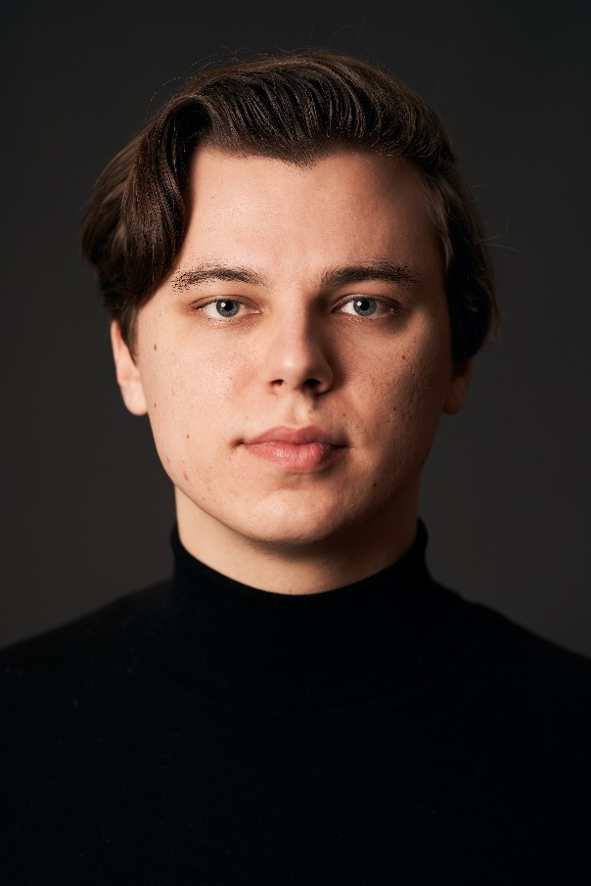**Dominik Čičak**

**Height** 6'2’’ (190 cm)

**Hair** Brown

**Eyes** Blue

**Training** East 15 Acting School (UK)

**Nationality** Croatian

**Natural Accent** General American

**Course** 3 Year BA in Acting (2018)

**Spotlight** 0932-7831-1349

**Website** https://dominikcicak.com/

**Languages** English*, Croatian*, German, Montenegrin*, Bosnian*, Serbian*, Slovenian*

**Television & Film**

|  |  |  |  |  |
| --- | --- | --- | --- | --- |
| **Year** | **Title** | **Role** | **Director** | **Production** |
| 2023 | The Ark | Harris Beckner | Dean Devlin | NBC Studios |
| 2022 | The Ipcress File | CIA Man | James Watkins | ITV Studios |
| 2022 | Što se bore misli moje | British Consul Fontainebleau | Milorad Milinković | Bombona |
| 2021 | Šťastný nový rok 2: Dobro došli | Željko | Jakub Kroner | Netflix |
| 2021 | Vreme Zla (Historical Drama) | Translator Schöller | Ivan Živković | Eye to Eye & United Media |
| 2021 | Dar Mar (Sitcom) | Policeman | Danijel Kušan | Nova TV |
| 2020 | Blago Nama (Sitcom) | Klima Majstor | Goran Rukavina | RTL Television |
| 2020 | Jugoslovenka (Historical Drama) | Lujo Lovrić | Roman Majetić | RTV Pink & Roman prod. |
| 2019 | Vrata do Vrata (Door to Door) | Boris (lead) / 120 episodes | Marko Manojlovic / Vlada Aleksic / Dejan Karaklajic | Met Ro Productions, Superstar TV (Serbia) |

**Theatre**

|  |  |  |  |  |
| --- | --- | --- | --- | --- |
| **Year** | **Title** | **Role** | **Director** | **Production** |
| 2018 | Three Kingdoms | Peeter Koepell / Georg Kohler | Tom Hughes | Corbett Theatre |
| 2017 | Generation Z or Uncertainty of a Scattered Mind | f1 | Eduardo Almeida | Corbett Theatre |
| 2017 | Richard III | Soldier / Bishop / Pallbearer | Mehmet Ergen | Arcola Theatre |
| 2017 | Love’s Labour’s Lost | Anthony Dull | Caroline Webster | East 15 Acting School |
| 2017 | That Kind of Life | Self (devised) | Dimitris Tsiamis | East 15 Acting School |
| 2016 | Wild Honey (Platonov) | Sergey Voynitzev | Caroline Webster | East 15 Acting School |
| 2016 | Europe | Berlin | Tom Hughes | East 15 Acting School |

**Email: dominik.cicak@gmail.com**

**Radio and Voiceover**

|  |  |  |  |  |
| --- | --- | --- | --- | --- |
| **Year** | **Title** | **Role** | **Director** | **Production** |
| 2021 | Corona Quake | British Newscaster | Vladimira Spindler | MP Film Production |
| 2017 | The Wall | Paul | Jeremy Mortimer | East 15 Acting School |
| 2016 | Tesla | Voice over / Danilo | Luke Clarke | Alchemist Theatre |

**Skills**

|  |  |
| --- | --- |
| **Accents & Dialects**: *(* = native)* | American-East Coast, American-Midwest, American-Standard*, Canadian, Czech, East European, English-Standard, French, German, Italian, Polish, RP, Russian, Serbian |
| **Languages**: *(* = Native/Fluent)* | Croatian*, English*, German, Montenegrin*, Bosnian*, Serbian*, Slovenian* |
| **Music & Dance**: *(* = highly skilled)* | Bass (singing), Bass-Baritone, Foxtrot, Lindy Hop, Period Dancing, Polka, Sight-Reading, Waltz |
| **Performance**: | Audio Drama, Clown, Comedy, Comedy Improv, Laban Training, Living History, Presenting, Public Speaking, Radio Drama, Story Telling, Verbatim Theatre, Voice Acting, Voice Over |
| **Sports**: *(* = highly skilled)* | American Football, Baseball, Basketball*, Cricket*, Cycling, Football*, Ice Hockey*, Ice Skating*, Skiing*, Swimming, Athletics, Fencing, Stage Combat, Horse-riding |
| **Vehicle Licences**: | Car Driving Licence |
| **Other Skills**: | Chess, Improvisation, Narration, Video Gaming, Writer |
| **Special Interests:** | Comedy, history, aviation, reading, and sports. |